# Basic Python Syntax

### Comments in Python

Comments can be used to explain Python code.

Comments can be used to make the code more readable.

**Comments can be used to prevent execution when testing code.**

Comments **starts with a # (hash)** , and Python will ignore them

#### Single line comment

**#this is single line comment**

#### Multiple line comments.

Another way of doing this is to use triple quotes, either ''' or """.

These triple quotes are generally used for multi-line strings. But they can be used as a multi-line comment as well. Unless they are not docstrings, they do not generate any extra code.

"""  
This is a comment  
written in  
more than just one line  
"""  
print("Hello, World!")

### Docstrings in Python.

A docstring is short for documentation string.

Python docstrings (documentation strings) are the [string](https://www.programiz.com/python-programming/string) literals that appear right after the definition of a function, method, class, or module.

Triple quotes are used while writing docstrings. For example:

def double(num):

"""Function to double the value"""

return 2*num

Docstrings appear right after the definition of a function, class, or a module. This separates docstrings from multiline comments using triple quotes.

The docstrings are associated with the object as their __doc__ attribute.

So, we can access the docstrings of the above function with the following lines of code:

def double(num):

"""Function to double the value"""

return 2*num

print(double.__doc__)

**Output**

Function to double the value

## Triple, Double and Single quotes

### Single and double

'...' and "..." are equivalent. If you have an apostrophe in the string, it is easier to use "..." so you don't have to escape the apostrophe. If you have quotes in the string, it's easier to use '...' so you don't have to escape the quotes.

### Triple quotes

Triple quotes (both varieties, """ and ''' are permitted) allow the string to contain line breaks. These are commonly used for **docstrings** (and other multi-line comments, including "commenting out" code) and for embedded snippets of other computer languages such as HTML and SQL.

**You can assign a multiline string to a variable by using three quotes.**

## Python Back slash

in Python strings, **the backslash "\"** is a **special character**, also called the "**escape**" character.

It is used in representing certain whitespace characters:

"\t" is a tab,

"\n" is a newline, and

"\r" is a carriage return.

print 'apple\torange'

apple orange

>>> print 'apple\norange'

apple

orange

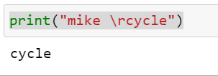

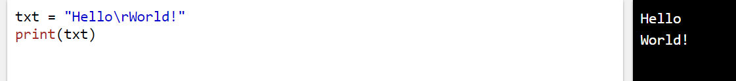

## Escape Sequence in Python

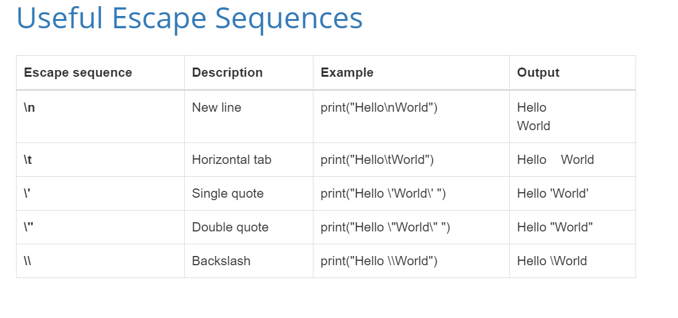

## Python **String Concatenation**

String concatenation means add strings together.

Use the + character to add a variable to another variable: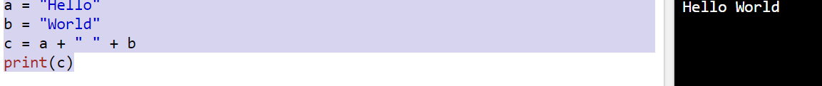\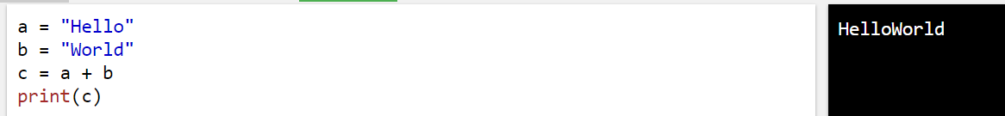

## Formatted output

### Center ,.ljust, .rjust

## indentation

**Python** uses **indentation** to indicate a block of code.

# Strings

Strings in python are surrounded by either single quotation marks, or double quotation marks.

